

**Department of Computer Science and Software Engineering**

**INTERNATIONAL ISLAMIC UNIVERSITY ISLAMABAD**

**Project of:**

**CS - 242 _ IDS – BSSE/F20**

**Submitted by:**

**\*\*\*Zubair Khan\*\*\***

**4150-FBAS/BSSE/F20** **Submitted to:**

**Mr. M IMRAN SAEED**

# 

# DATABASE OF ONLINE BANK MANAGEMENT SYSTEM:

1. Introduction:

Online Banking System provides many benefits to bank consumers in terms of easy, fast, fast, and secure transactions, either through Internet, mobile phone, or other electronic devices. Nowadays Online Banking Project has become one of the most essential parts of our daily life. Online Banking Management System is the provision of providing financial services using electronic communication and computation. In practice, the Online banking system includes e-payment, e-shopping, and e-banking.

The banking management system sector has seen the greatest expansion in the past year and with the number of customer interactions increasing the day it has all the records in the database.

When it comes to managing the money or valuable assets it automatically becomes a crucial matter for the service provider and the client as well for the trustworthiness. The banking management system is one of the most complex systems because the things it covered under the roof for transparency among the customers.

From managing the customer information, and account information to the transaction happening every minute or second. It does not only preserve the details of the transaction and other information but generates the report to further banking functions. In this banking management system, many operations are automated which eases the work for the working of the bank.

This reduces the requirement for manual labor and the automated tasks will be error-free as they will only work as they are programmed whereas doing work manually there is always a possibility of human error.

1. Existing System:

The existing bank system is slow as every task is being performed by a human being and comparing the computer task speed with a computer is not fair. The complexity of this system is increased when an increase in the number of customers and with that there will be several transactions will be performed now everything needs to log in to a file for reference in the future which is simply not the kind of scenario we need at this time.

* 1. Drawbacks in Existing System:

Some other drawbacks of the existing system:

* Less security of customer and bank information.
* Require more physical work and manpower.
* All the manual entry and editing will take more time.
* No level of clearance for the different levels of employees.
* Safety of paper documents from the disaster.
* No backup of the information.

By looking at disadvantages these are pretty serious for any banking system as they are capable of bringing down the whole system. Digitalization in the banking system, will not only achieve its goals and also will give some benefits like less manual calculation will be required.

1. Proposed System:

**Some improvements by executing the proposed system:**

More secure information will give a layer of security of authentication and authorization.

* Required very little manpower.
* Simplify the problem of editing.
* Maintain the clearance level by the hierarchy.
  1. Advantages of Proposed System:

The information will be secure from the different types of disasters as there will be an automatic backup system for the customer and bank information.

Maintain data integrity Validate the manual calculations to avoid calculation errors.

* Safeguard the data accuracy.
* More reliable and efficient.
* More user-friendly interface.

1. Data Requirements
   1. Entity Classes:

This database includes 5 entity classes and each entity class has its attributes:

* Branch
* Customer
* Employee
* Loan
* Transaction
  1. Attributes of Entity Class:

Each of the above-listed entity classes has the following attributes:

1. **Branch**

* Branch ID
* Branch Name
* Country Name
* City Name
* Phone No

1. **Customer**

* Account No
* Account Name
* Address
* Balance
* Date Of Birth

1. **Employee**

* Employee ID
* Employee Name
* Basic Pay
* Gross Pay
* Net Pay

1. **Loan**

* Loan ID
* Loan Type
* Loan Amount
* Interest Rate
* Due Amount

1. **Transaction**

* Transaction ID
* Branch ID
* Account No
* Withdraw
* Deposit
* Transaction Date
  1. Bubble Chart:

It is a graphical tool to represent the relationship or association between attributes of an entity class.

The followings are the Bubble charts of different Entity Classes;

1. Branch:

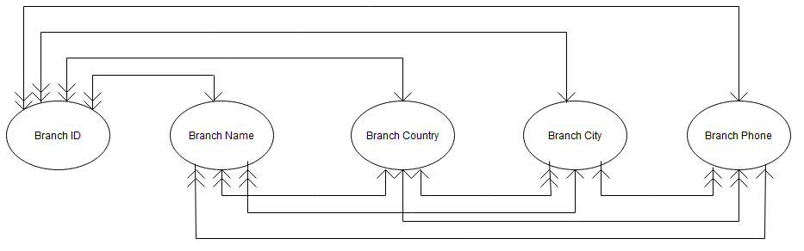

Figure:1.1. Bank Branch

**Candidate Key:**

* Branch ID

**Primary Key:**

* Branch ID

**Secondary Key:**

* Branch City

1. Customer:

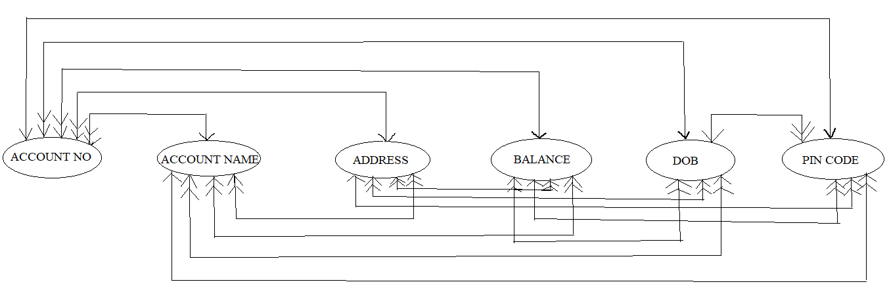

Figure:1.2. Bank Customer

**Candidate Key:**

* Account No
* PIN CODE

**Primary Key:**

* Account No

**Alternate Key:**

* PIN CODE

**Secondary Key:**

* Address

1. Transaction:

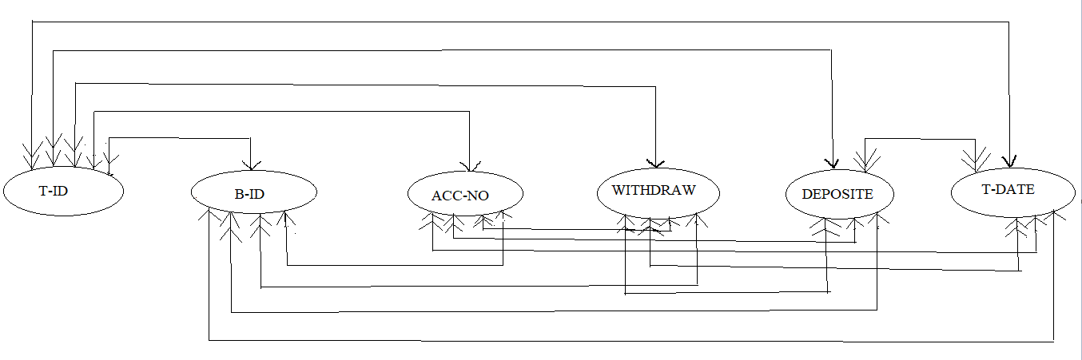

Figure:1.3. Bank Transaction

**Candidate Key:**

* T-ID
* B-ID
* Account No

**Primary Key:**

* T-ID

**Alternate Key:**

* Account No

**Secondary Key:**

* T-Date

1. Employee:

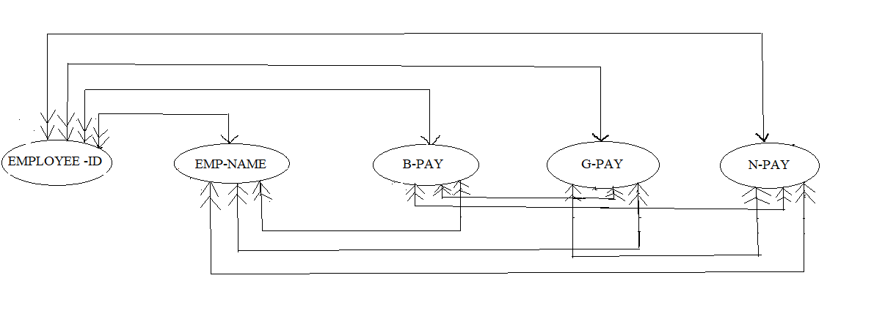

Figure:1.4. Bank Employee

**Candidate Key:**

* Employee-ID

**Primary Key:**

* Employee-ID

1. Loan:

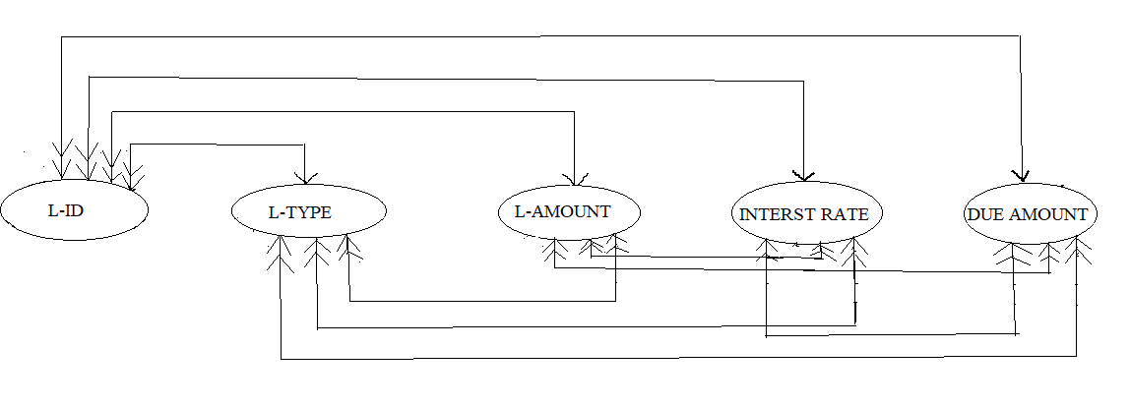

Figure:1.5. Bank Loan

**Candidate Key:**

* L-ID

**Primary Key:**

* L-ID

**Secondary Key:**

* L-Type
  1. Entity Relationship Diagram:

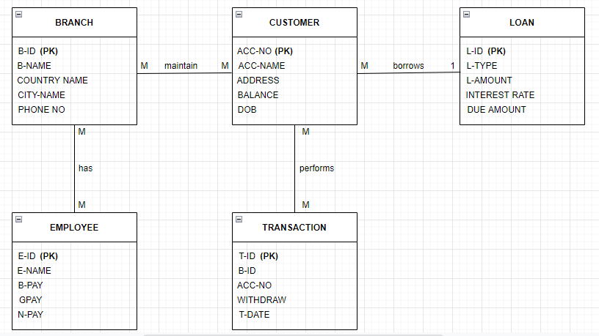

**TABLES:**

1. 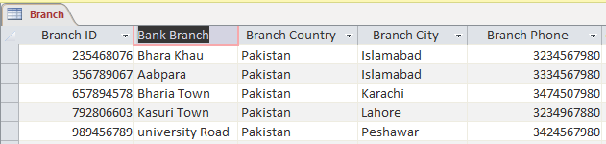**Branch**
2. **Customer:**

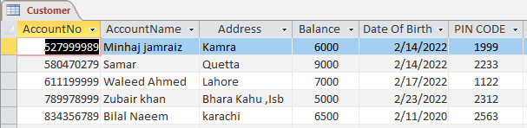

1. **Employee:**

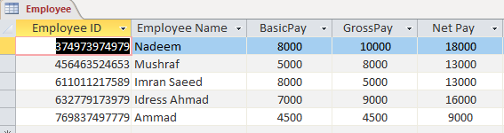

1. **Transaction:**

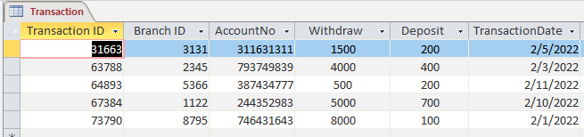

1. **Loan:**

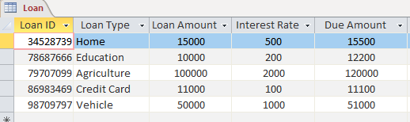

(APPENDIX-A )

1. 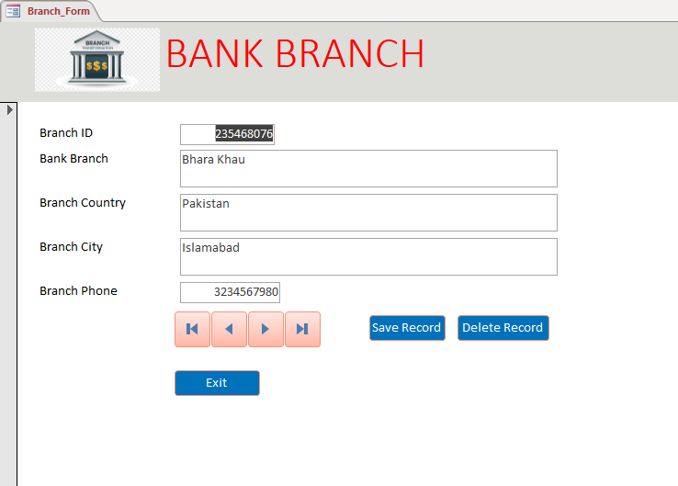**FORM:**

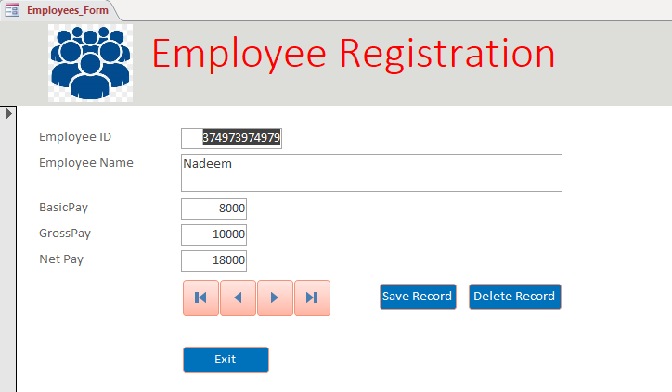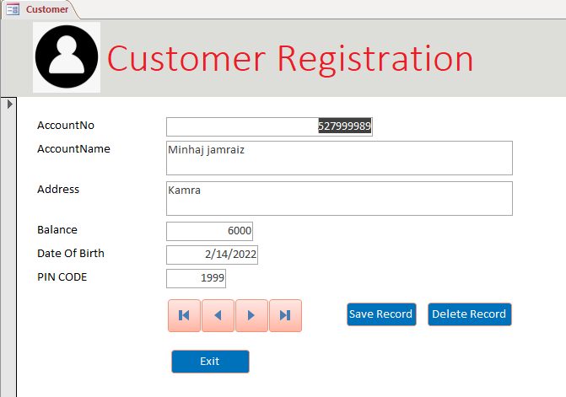

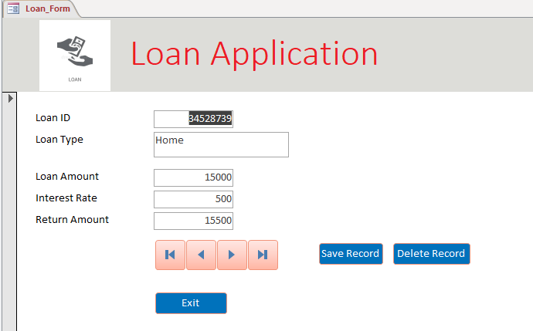

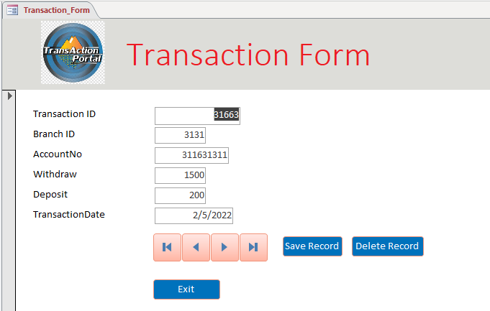

1. 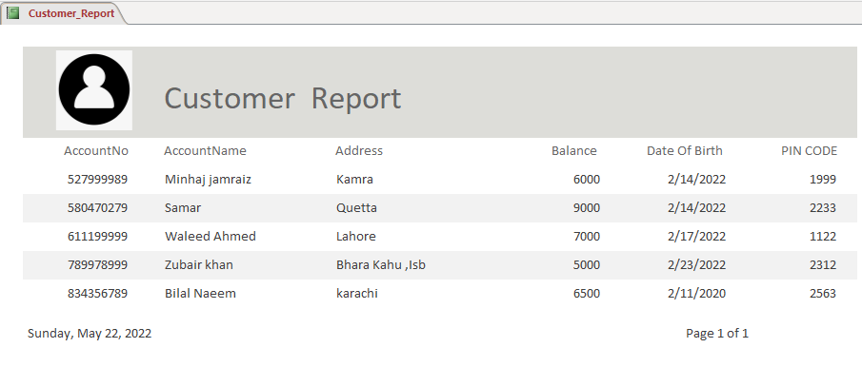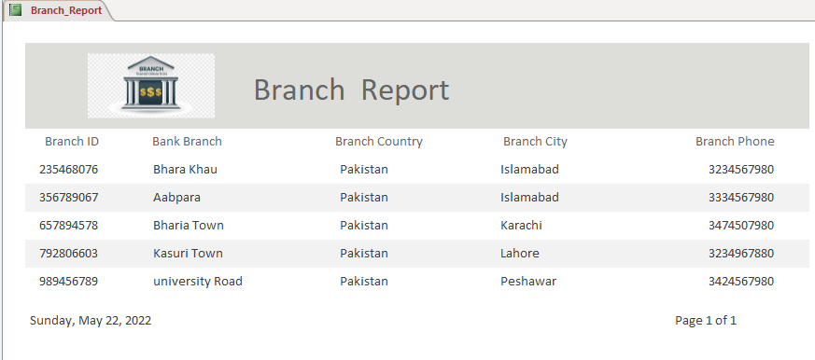**Report:**

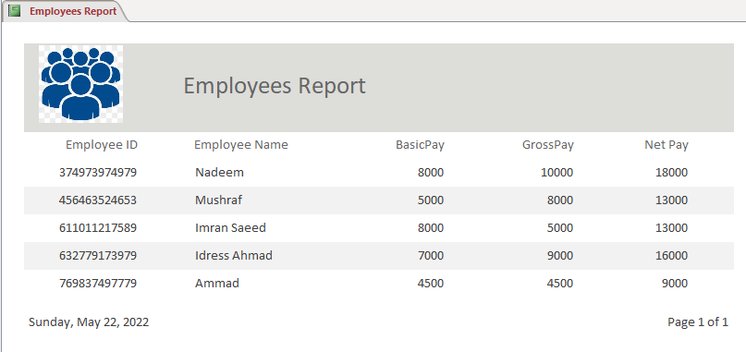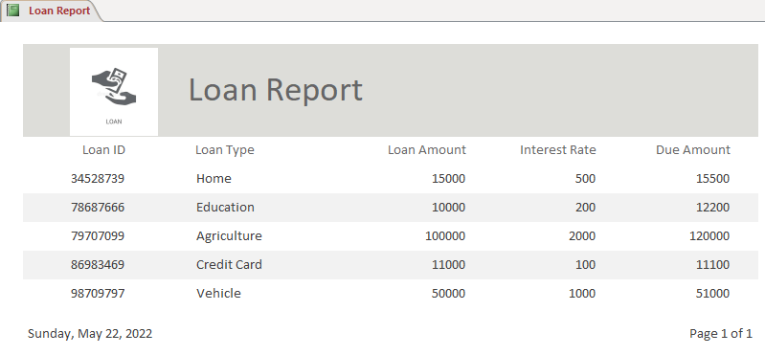

**\*THANK YOU\***